PREREQUISITES

IBM CLOUD SERVICES

Successfully created account in IBM Cloud

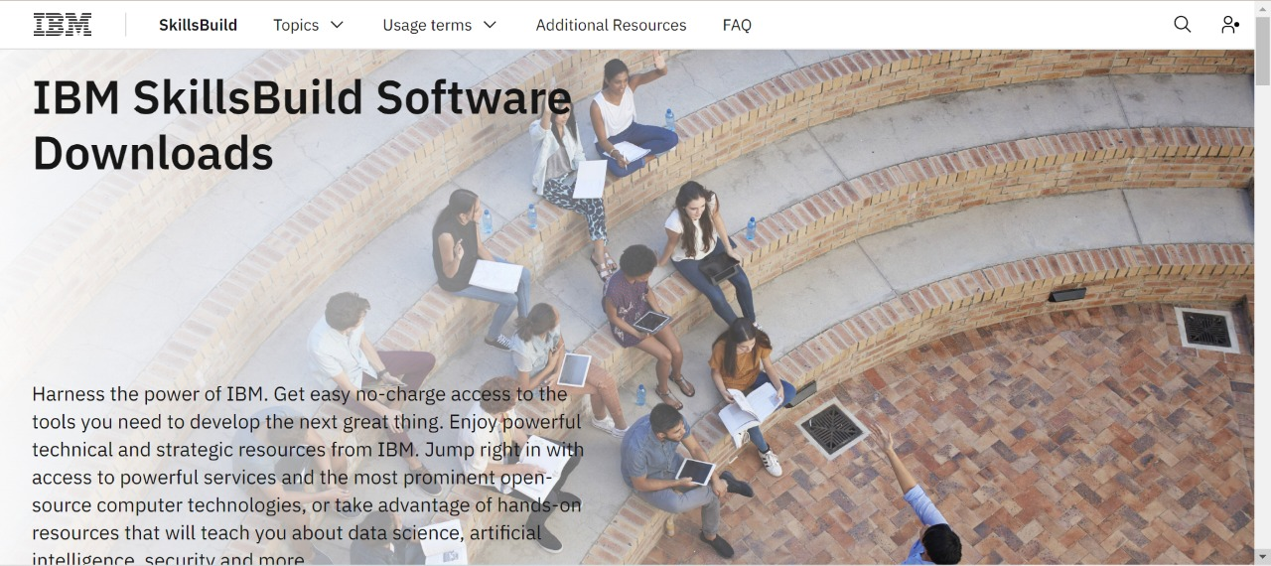

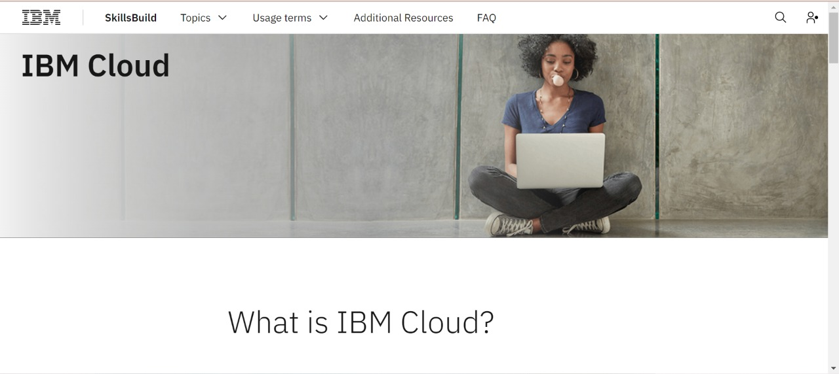

**TEAM LEADER:**

HARSHAVARTHANA M (1904012)

**TEAM MEMBERS:**

AMIRTHAVARSHINI R (1904001)

ATCHAYA B (1904004)

RAGHAVI R (1904038)

RAKSHEKA R (1904039)